**Name:** Anshul Shirbhate

**Roll No:** D – 5

**Practical No:** 9

**Practical Aim:** Client Server communication using socket programming.

**Code:**

**Client Side:**

import java.io.*;

import java.net.*;

public class MyClient {

public static void main(String[] args) {

try{

Socket s=new Socket("localhost",6665);

DataOutputStream dout=new DataOutputStream(s.getOutputStream());

dout.writeUTF("Hello Student");

dout.flush();

dout.close();

s.close();

}catch(Exception e){System.out.println(e);}

    }

    }

**Server Side:**

import java.io.*;

import java.net.*;

public class MyServer {

public static void main(String[] args){

try{

ServerSocket ss=new ServerSocket(6665);

Socket s=ss.accept();//establishes connection

DataInputStream dis=new DataInputStream(s.getInputStream());

String str=(String)dis.readUTF();

System.out.println("message= "+str);

ss.close();

}catch(Exception e){System.out.println(e);}

}

}

**Outputs:**

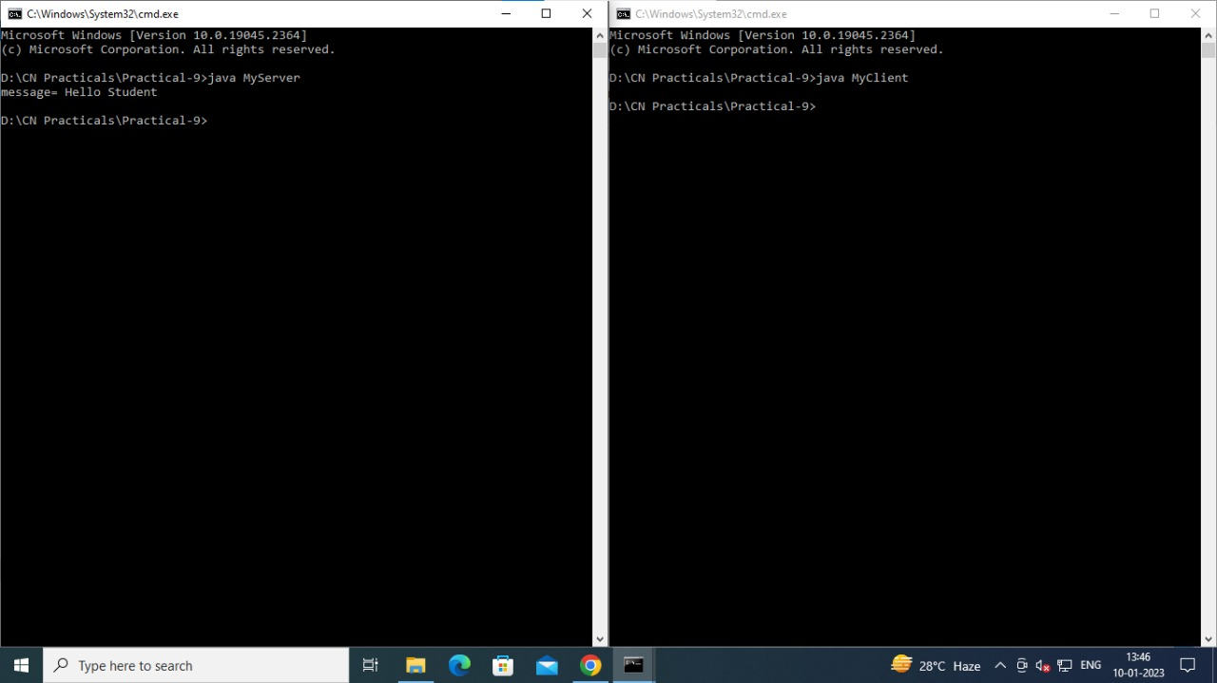

**Conclusion:**

In this practical, we learnt about socket programming and how to code in java to start a server and client communication.